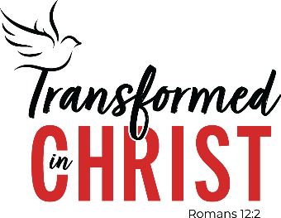

42nd Biennial LWML Convention
July 8 – 11, 2027
Oklahoma City

Do not be conformed to this world, but be transformed by the renewal of your mind, that by testing you may discern what is the will of God, what is good and acceptable and perfect. Romans 12:2

VACANCIES ON OUR 2027 HOST COMMITTEE:

Hospitality Chairman
Workers’ Room Director
Intermediate Child Care Director
Food Services Traffic Supervisor Director
Hotel Shuttle Busses Director
VIP Drivers Director
Information & Wheelchair Director
On-Site Hostesses Director
Main Floor Ushers Director
Properties Director
Signage Support Director

Please contact Karen Karner, hcc2027@lwml.org, if you are interested in serving in one of these positions.

